Bahria University,

Karachi Campus



LAB EXPERIMENT NO.

**5**

LIST OF TASKS

|  |  |
| --- | --- |
| TASK NO | OBJECTIVE |
| **1** | **Write a python program that can find the value of tan(0.12) using Newton’s forward interpolation formula** |
| **2** | **Write a python program implementing the backward interpolation formula** |
|  |  |
|  |  |

Submitted On:

**Date: 26/10/2023**

**Task No. 01:**

**Write a python program that can find the value of tan(0.12) using Newton’s forward interpolation formula, with considering to the following data points:**

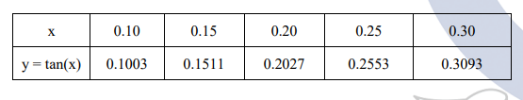

**Solution:**

def calculate_u(u, n):

temp = u

for i in range(1, n):

temp = temp * (u - i)

return temp

def factorial(n):

f = 1

for i in range(2, n + 1):

f *= i

return f

def display_forward_difference_table(x, y, n):

for i in range(n):

print(x[i], end="\t")

for j in range(n - i):

print(y[i][j], end="\t")

print("")

def interpolate(x, y, n, value):

sum = y[0][0]

u = (value - x[0]) / (x[1] - x[0])

for i in range(1, n):

sum = sum + (calculate_u(u, i) * y[0][i]) / factorial(i)

return round(sum, 6)

n = int(input("Enter the number of data points: "))

x = []

y = []

for i in range(n):

x_val = float(input(f"Enter x[{i}]: "))

y_val = float(input(f"Enter y[{i}]: "))

x.append(x_val)

y.append([0] * n)

y[i][0] = y_val

for i in range(1, n):

for j in range(n - i):

y[j][i] = y[j + 1][i - 1] - y[j][i - 1]

print("\nForward Difference Table:")

display_forward_difference_table(x, y,n)

value = float(input("\nEnter the value to interpolate at: "))

result = interpolate(x, y, n, value)

print(f"\nInterpolated value at {value} is approximately {result}")

**Output:**

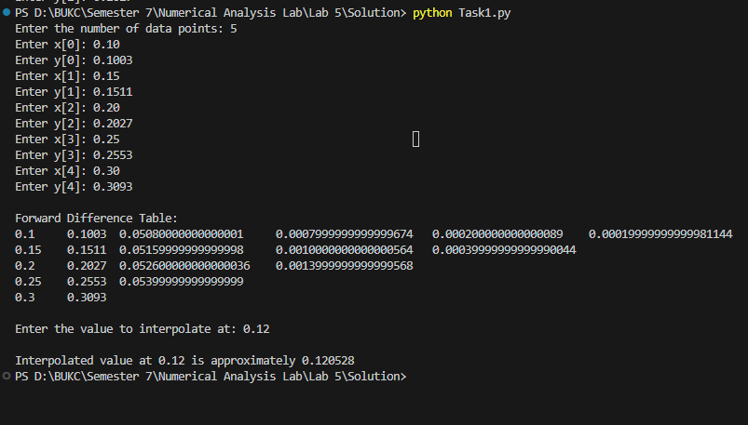

**Task No. 02:**

**Write a python program implementing the backward interpolation formula that considers the following data points, and**

**a. Find the value of y at x = 300**

**b. Find the value of y at any given user input**

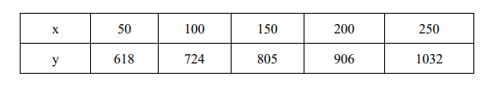

**Solution:**

def calculate_u(u, n):

result = u

for i in range(1, n):

result *= (u + i)

return result

def factorial(n):

result = 1

for i in range(2, n + 1):

result *= i

return result

n = int(input("Enter the number of data points: "))

x = []

y = []

for i in range(n):

x_val = float(input(f"Enter x[{i}]: "))

y_val = float(input(f"Enter y[{i}]: "))

x.append(x_val)

y.append([0] * n)

y[i][0] = y_val

for i in range(1, n):

for j in range(n - 1, i - 1, -1):

y[j][i] = y[j][i - 1] - y[j - 1][i - 1]

for i in range(n):

for j in range(i + 1):

print(y[i][j], end="\t")

print()

value = float(input("Enter the value to interpolate: "))

result = y[n - 1][0]

u = (value - x[n - 1]) / (x[1] - x[0])

for i in range(1, n):

result += (calculate_u(u, i) * y[n - 1][i]) / factorial(i)

print(f"\nThe interpolated value at year {value} is approximately {result}")

**Output:**

**value of y at x = 300:**

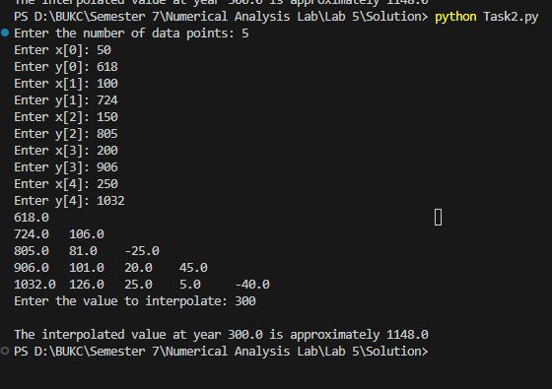

***value of y at any given user input*** 